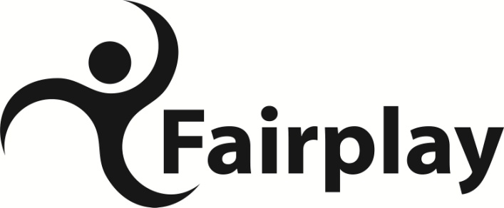
2025 / 26

Dear Parent/Carer

Thank you for your enquiry regarding Fairplay services. Fairplay provides a wide range of services and activities for children and young people with disabilities from 0 to 25 years old. By becoming a member of Fairplay you are able to access the following depending on your child’s age;

- Youth clubs and activity days in Chesterfield for ages 12-25 years
- Children’s Playschemes and trips for ages 5-12 years
- Trips and outings for all the family
- A network of parent support groups and information sessions
- Children’s and Young People’s Christmas party
- Fundraising events
- Under 5’s Play Sessions & Parent Support
- Overnight support services
- Independent Living Groups – SCaRT, Moving Forward & Enterprise (25 years)
- Independent Living Group Plus (25 years)
- Saturday projects
- Fully accessible centre and garden
- Sibling support sessions

We have enclosed a Membership Form for you to complete. Please provide as much information as you can and return the form to Fairplay. On receipt of your form you will be contacted by the Co-ordinator for your area who will arrange a mutually convenient appointment for you to visit the centre to discuss these services in more detail.

It is vital we have up to date information including contact telephone numbers in case of emergency as well as medication requirements. Please complete a separate form for each child if more than one child from your family will be attending playschemes and/or youth activities. In order to meet the needs of our members and ensure their safety at all times we cannot accept any child or young person without an up to date Membership Form.

Continued…….

Fairplay
Alexandra Road West
Chesterfield
S40 1NP

Tel 01246 203963
Email office@fair-play.co.uk
Website www.fair-play.co.uk

A Registered Charity No 1128629 working in North Derbyshire to improve opportunities for children and young people with disabilities and their families
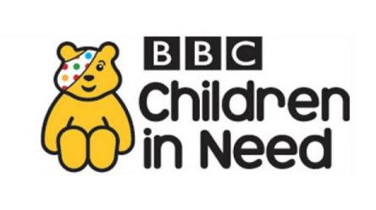

Fairplay is a company limited by guarantee
Registered Company No. 06826731

Fairplay receives financial support from:
Derbyshire County Council
Derbyshire County CCG

Payment

The annual fee is £27 per family per year from 1 April to 31 March. Fairplay is registered for Gift Aid and is able to claim 25p in every £1 raised or donated, including the annual membership fee. The membership fee will be invoiced to you. The membership of £27 per year helps towards the cost of keeping families up to date with information regarding our services.

I would like to take this opportunity to thank you for becoming a member of Fairplay and I hope you enjoy a full year of member benefits.

Yours sincerely
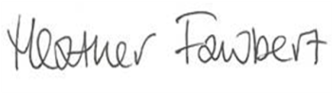
Heather Fawbert
Chief Executive

Encs
- Membership Form
- Terms and conditions of membership

